**Instructions:** Complete the following tasks and bring your homework to the next class.

**Part I:** Follow the link to an online form and complete the quiz.

<https://forms.office.com/Pages/ResponsePage.aspx?id=_cbR8PDfakiOkc_v78fZjb6RAPpAEUxIprFyhrVCyVhUMzZRNE9QOTdJOUE0S0RQTU8zUUlPRVpRUi4u>

**Part II:** Read the following text and, in your own words, define the two terms below the extract.

**Cohesion:**

__________________________________________________________

__________________________________________________________

**Coherence:**

__________________________________________________________

__________________________________________________________

__________________________________________________________

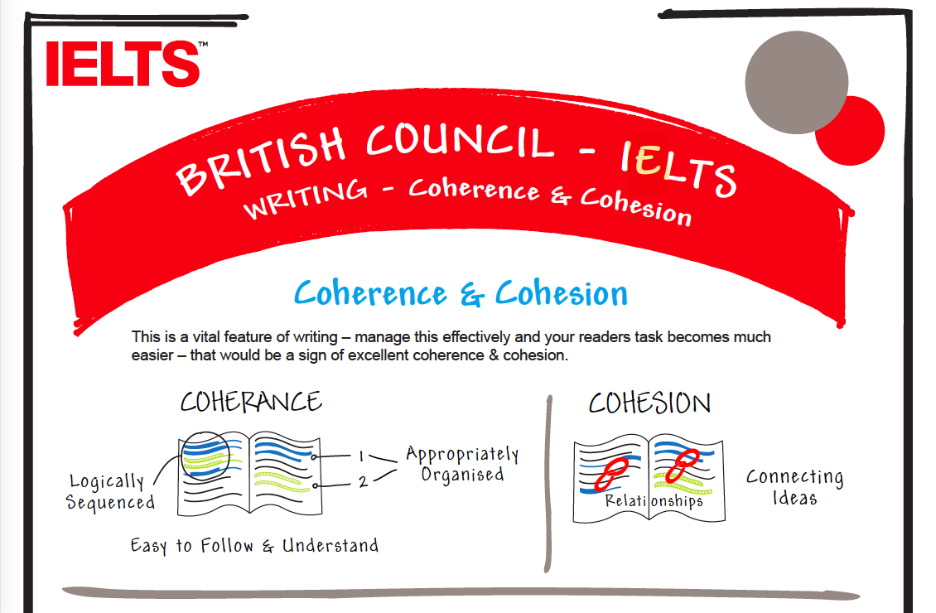

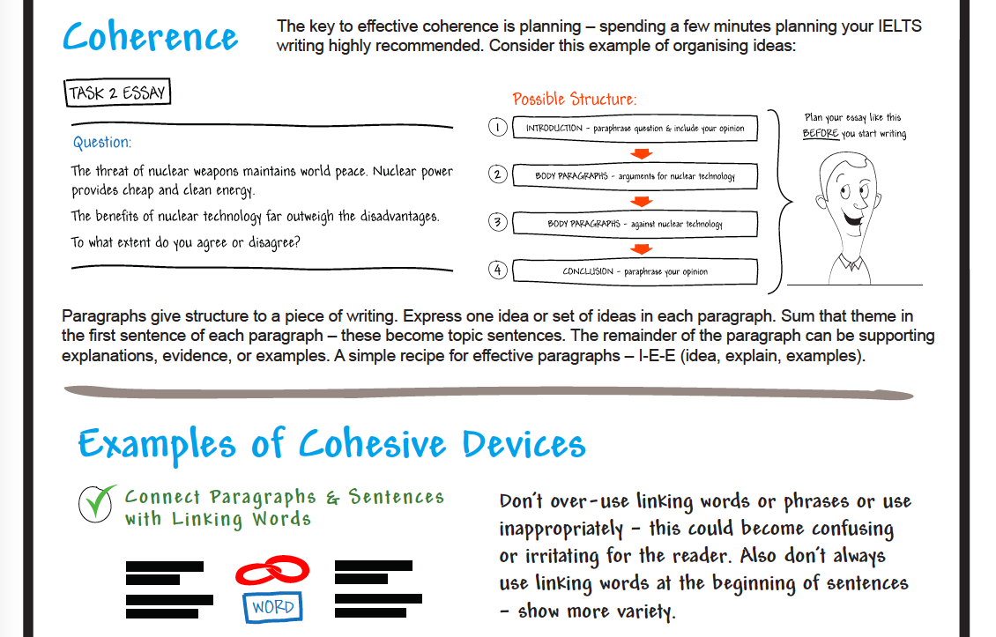

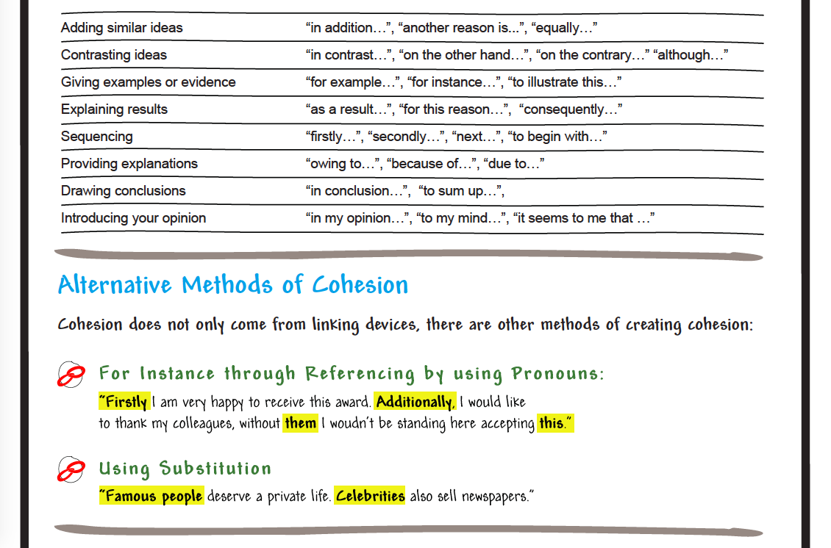

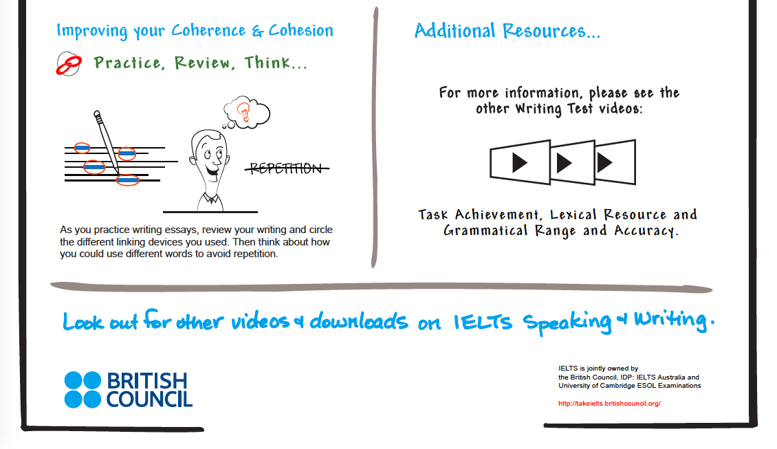

**Part III:** Look at the essay below. Identify ways in which the essay could be improved and edit/correct the essay. Use the information given to you in **Part II** as a guide.

This essay will look at how young people can be encouraged to vote in two main ways.

The government should devise campaigns to inform young people and increase young people’s awareness of the importance of voting.

Campaigns to inform young people should be as informal as possible and use electronic media such as blogs, websites or any other means that are accessible to young people’s generation. Later on, the medium could also include newspapers and posters.

The contents of the campaigns to inform young people should include the fact that voting is the right of every citizen, and state the benefits of voting such as the ability to choose the right representative for a particular area. It is also important to inform the young people that it is easy for them to vote.

After all the the campaigns to inform young people are done through the many information channels, the government may also promote voting by educating people in colleges, student guilds and other student organizations.

By taking these approaches, hopefully more young people will vote.

* Els van Geyte, *Learn to write better academic essays,* (London: Collins, 2013),p. 23.

**Part IV:** Read the following question and write a thesis statement (claim) and three topic sentences (reasons) to support.

‘Some people argue that technological inventions, such as smartphones, are making people less socially interactive’ Do you agree?

Claim: _______________________________________________________________________

_____________________________________________________________________________.

Data 1: _______________________________________________________________________

_____________________________________________________________________________.

Data 2: _______________________________________________________________________

_____________________________________________________________________________.

Data 3: _______________________________________________________________________

_____________________________________________________________________________.